# ER diagram

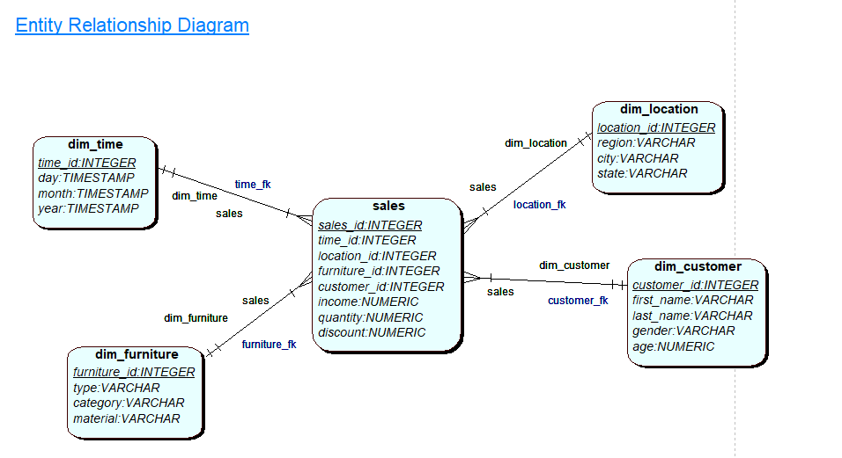

1. Find the quantity, the total income and discount with respect to each city, type of furniture and the month

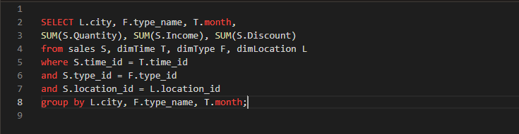

1. Find the average quantity, income and discount with respect to each country, furniture material and year

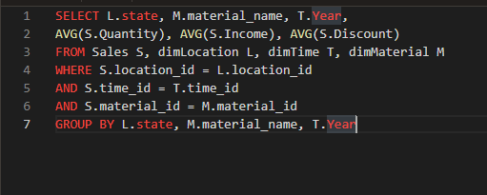

1. Determine the 5 most sold furniture during the May month

